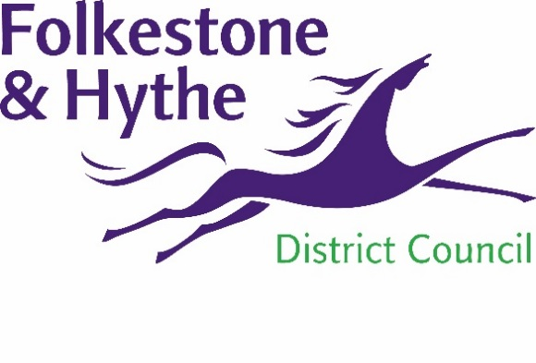
NEWS RELEASE

30 November 2021

PRINCES PARADE SCHEME GETS GOVERNMENT BACKING

The innovative Princes Parade scheme has received a major boost thanks to a £2m grant from central government.
Money from the Brownfield Land Release Fund will help prepare the former municipal waste site for development ahead of the construction of 150 housing units.
This forms part of the project that will also deliver a new leisure centre, accessible green open spaces, additional play areas, better access to the canal and beach, and a widened promenade for the community to enjoy.
Cllr David Monk, F&HDC Leader, said: “I’m delighted the government agrees with the benefits of this project. It will transform a disused brownfield site with poor ecological credentials and provide quality housing to address local needs.
“This isn’t the first time we’ve received funding for this development. Unfortunately we lost the first grant – a significant investment into the district – due to the failed and time-consuming judicial review and attempted appeal.
“To receive such backing for a second time is testament to the thoroughness of our work throughout the formation of this scheme, which continues to progress at a good pace despite the best efforts of a small number of people.”
The Brownfield Land Release Fund supports local authorities to bring forward brownfield sites for housing development and self and custom-built serviced plots.
Housing minister Christopher Pincher MP added: “Our brownfield-first approach is transforming underused sites into thriving communities where people want to live, work and visit.
“The investment we are announcing today will help people onto the property ladder, create jobs, deliver new infrastructure and provide a boost to local communities as we level up across the country.”
Visit folkestone-hythe.gov.uk/princesparade for more information about the development and the progress being made.

ENDS
Notes to Editors
For more information, please email communications@folkestone-hythe.gov.uk

Follow us on Facebook: @FolkestoneandHytheDC
Follow us on Twitter: @fstonehythedc
Follow us on Instagram: @folkestonehythedc
Follow us on LinkedIn: Folkestone & Hythe District Council

